Local patent application

According to the Intellectual Property Act, No. 36 of 2003 of Sri Lanka, an application for the grant of a patent shall be made to the Director-General in the prescribed form and shall contain,

Patent application Checklist | //NA
- Completed application form- Two Copies
- Patent specification,
  - Description
    - Title of the invention
All pages of the patent specification should be numbered

    - Technical field
    - Background art
    - Technical problem
    - Technical solution
    - Brief description of drawing
    - Advantageous effects
    - Mode for invention
    - Industrial applicability
  - Claims
  - Abstract
  - Drawings (if any)

- Date and number of any application for a patent filed by the applicant abroad if any, relating to the same, or essentially the same invention as that claimed in the present application
- When the applicant is a company/institution/ university, Assignment letter signed by all inventors consenting for assignment of IP to CEO of company/ Head of Institution/ Vice Chancellor of University
- Application fee

* Use only plain, white, A4 size papers and type set documents the whole document.
Use a copy of this sheet to confirm if the items in the checklist are ready for submission by placing either of //NA

The specification of the patent has to follow the below structure
- Description

- Title of the invention:
Your title should sufficiently describe the invention and it should include the keywords of the work. It must be specific and introduce the invention without any abbreviations and should indicate the category of the invention.

- Technical Field:
Specify the technical field that your invention belongs to. This should describe the scope of the invention and subject matter of the invention on which it relates.

- Background art:
This is a simple version of a literature review. You can preferably cite the documents related to your creation. This describe what others have done in the field and what problems have not been solved by prior work. Prior art details of granted patents and patent applications which have been filed all over the world and research publications could be mentioned to complete the background art.

- Technical problem:
Describe the specific technical problem/s addressed by your invention.

- Technical Solution:
Describe how does your invention addresses the above-mentioned technical problem.

- Brief description of drawings:
Briefly describe the figures in drawings if any.

- Advantageous effects:
Describe the advantageous effects of your invention compared to the existing solutions/inventions.

- Mode for invention:
Disclose the invention in an understandable manner, sufficiently clear. You should write a complete description about the invention and the process you used to develop it. This should be sufficiently clear to be evaluated as to its novelty, inventive step and industrial application and to be carried out by a person having ordinary skill in the relevant art. You should include all the parameters (as a fair range to avoid any disputes or infringements) with correct units and conditions required to develop your creation. Refer to the drawings if appropriate.

- Industrial Applicability:
State the industrial applicability of your invention.

- Claims
Define the invention steps that thought to be new and inventive over other prior art. Draft each claim as a single sentence and must include all the essential features that are considered to be inter-related to the invention.
There must be at least one main claim which gives all the essential features and their interrelation. Other claims may introduce additional features of the invention.
Claims can be drafted only for technical features of the invention. Make them clear and concise and be supported by the description and should be based on the description. This means the claims must be fully explained in the description. If there are several claims, they shall be numbered consecutively in Arabic numerals.
Ex:
- A method of creating a bullet resistant glass screen consisting essentially of
- a plurality of sheets of glass,
- each sheet of glass having a front and rear surface to each of which is applied a shatter resistant film thereby defining a laminate,
- said shatter resistant film being a means for increasing the resistance of the sheet to shattering,
- each laminate being separated from a neighbouring laminate by a separation in the range 1-100 mm. as measured between opposed surfaces
- wherein said separation between each laminate is filled with air.
2. A bullet resistant glass screen as claimed in claim 1 wherein said glass sheets are 2-12 mm thick.
3. A bullet resistant glass screen as claimed in claim 1 wherein said film comprises a polyester film.
4. A bullet resistant glass screen as claimed in claim 3 wherein said glass sheets are 2-12 mm thick.
Claims should be drafted in correct format. Each claim should consist of an introduction (A method of creating a bullet resistant glass screen), linking word (consisting essentially of) and body (features of the invention). The first claim is called “Independent Claim” that reflects the whole picture of the invention. The claim/s which depends on it is called dependent claim.

- Abstracts

A brief summary of the invention with 50 to 150 words. It should summarize the description, claims and any drawings.

- Drawings (if any)
This is optional. You can include drawings only if you think it will help to get a good understanding about your invention. If you include drawings number them and make them clear enough to see.

Example of an Assignment Letter:
To:
Director General
National Intellectual Property Office,
Sri Lanka.

Dear Sir/Madam,

Assignment of Intellectual Property Rights to the University of …………………………….

We hereby assign University of ……………………………………….. as the Assignee for the patent application titled ………………………………………….(Title) in which we are the inventors.

Thank you.

Yours Truly,

Inventor 1
Name: …………………………………………………… Date:………………………………………
Signature:……………………………………………..
Inventor 2
Name: …………………………………………………… Date:………………………………………
Signature:……………………………………………..
Inventor 3
Name: …………………………………………………… Date:………………………………………
Signature:……………………………………………..

How to Fill a Patent Application?
You can find the patent application for Sri Lankan patent applications from the web page of National Intellectual Property office. https://www.nipo.gov.lk/web/index.php?option=com_content&view=article&id=39&Itemid=158&lang=en#patents
There are four pages of the application with following cages to be filled.
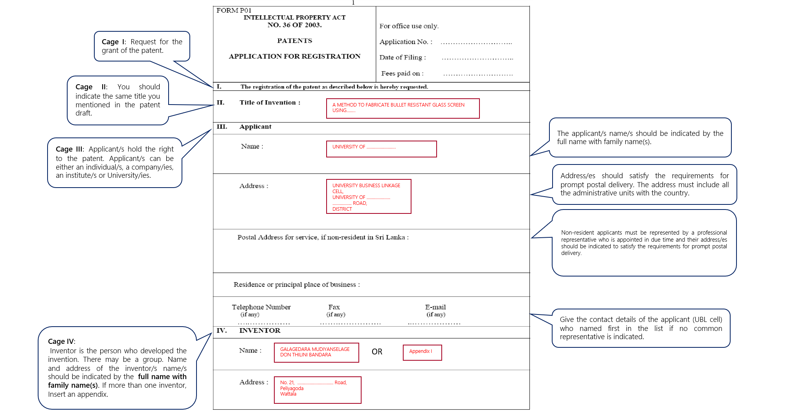
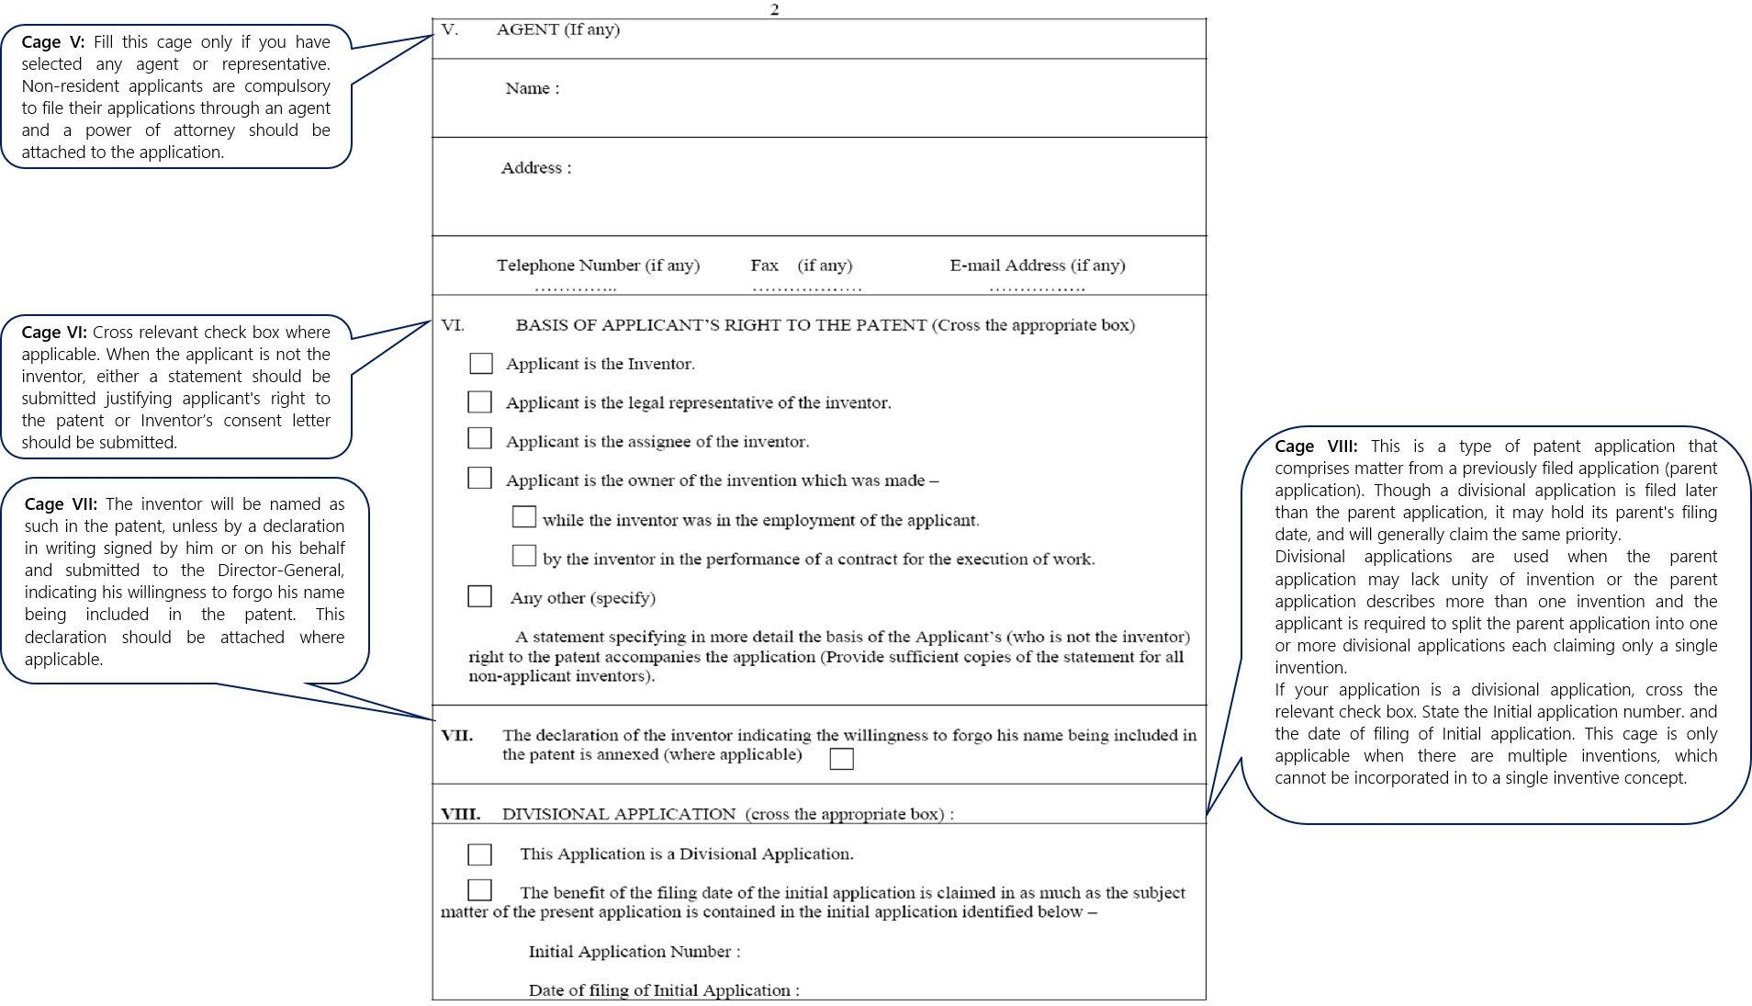
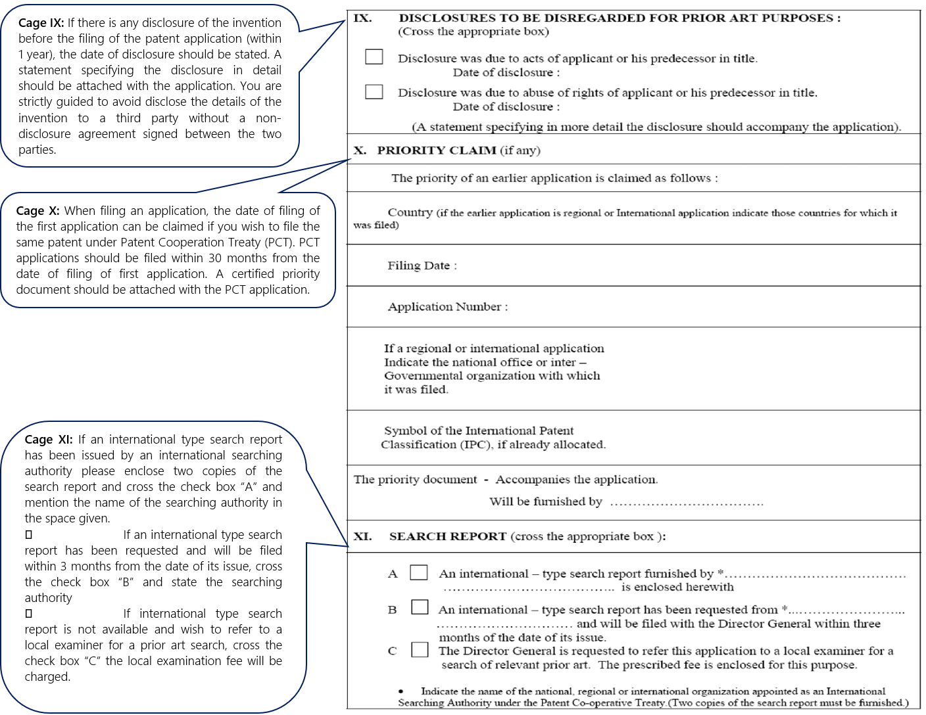

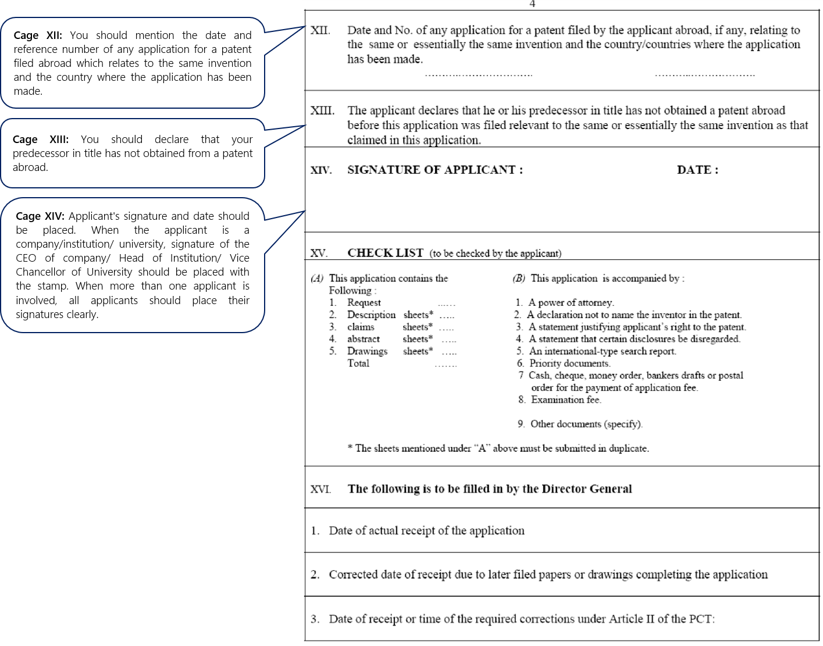

Patent corporation treaty system

A patent is valid only in the country where it is granted. However, if you wish to obtain patents from several other countries, The Patent Cooperation Treaty (PCT) makes it possible to seek patent protection for an invention simultaneously in each of a large number of countries by filing a single "international" patent application. However, The PCT system is a patent “filing” system, not a patent “granting” system. There is no “PCT patent” or “International Patent”.

The PCT system provides for
- an international phase comprising:
♣ filing of the international application
♣ international search and written opinion of the ISA
♣ international publication and
♣ international preliminary examination
- a national/regional phase before designated Offices
The decision on granting patents is taken exclusively by national or regional Offices in the national phase.

The simple overview of the timeframe within which the above-mentioned targets are to be achieved is given in Fig. 1
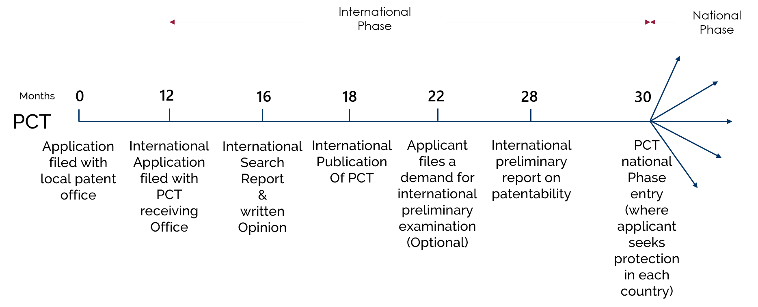
Figure 1: PCT application timeline Overview
RO | Competent International search Authority | Transmittal fee | International filing fee | Fee per sheet over 30 | Search fee
 |  |  |  |  | International searching Authority | Fee
IB | For nationals and residents of Sri Lanka: Australian Patent Office, European Patent Office, Korean Intellectual Property Office or Swedish Intellectual Property Office | USD 101 | USD 1,337 | USD 15 | Korea | USD 1,003
 |  |  |  |  | Australia | USD 1,507
 |  |  |  |  | European patent office | USD 1,950
 |  |  |  |  | Sweden | USD 1,950
Receiving office and Language: The international application must be filed with a competent receiving Office which is International Bureau of WIPO for the nationals and residents of Sri Lanka. If the international application is filed in a language other than Arabic, Chinese, English, French, German, Japanese, Korean, Portuguese, Russian or Spanish a translation of the international application will need to be furnished for the purposes of international search and/or international publication. In Sri Lanka, Translation of international application is required into English.

The elements of the international application must be arranged in the following order:
- Request
- Description,
- Claim(s),
- Abstract,
- Drawing(s) (if any)
similar to that of a local patent application.
All the sheets constituting the international application must be numbered in consecutive Arabic numerals.
The updated PCT applicant’s Guide can be found the below link.
https://www.wipo.int/pct/en/guide/index.html#L
By clicking on the country code LK in the Appendices of the above link, guidelines related to Sri Lanka can be obtained.
Request form and filled-in sample request form can be downloaded from the below link.
https://www.wipo.int/pct/en/forms/index.html
Administrative Instructions under the Patent Cooperation Treaty can be found on the following link.
https://www.wipo.int/pct/en/texts/ai/ai_index.html

